A company has the following scenario: There are a set of salespersons. Some of Them manage other salespersons. However, a salesperson cannot have more than one manager. A salesperson can be an agent for many customers. A customer is managed by exactlyone salesperson. A customer can place any number of orders. An order can be placed by exactlyone customer. Each order lists one or more items. An item may be listed in many orders. An item is assembled from different parts and parts can be

common for many items. One or more employees assemble an item from parts. A supplier can supply different parts in certain quantities. A part may be supplied by different suppliers.

(i) Identify and list entities, suitable attributes, primary keys, foreign keys and relationships to represent the scenario.

(ii) Draw an ER diagram to model the scenario using min-max notation.(9)

**Entities**: SALESPERSON,CUSTOMER,ORDER, ITEM, PART, SUPPLIER, EMPLOYEE

**Relationships**: SALESPERSON MANAGES SALESPERSON

SALESPERSON AGENT FOR CUSTOMER

CUSTOMERPLACESORDER

ORDER LISTS ITEMS

PART ASSEMBLEDINTO ITEM

EMPLOYEE ASSEMBLES ITEM

SUPPLIER SUPPLIES PART: SALESPERSON MANAGES SALESPERSON

SALESPERSON AGENT FOR CUSTOMER

CUSTOMERPLACESORDER

ORDER LISTS ITEMS

PART ASSEMBLEDINTO ITEM

EMPLOYEE ASSEMBLES ITEM

SUPPLIER SUPPLIES PART

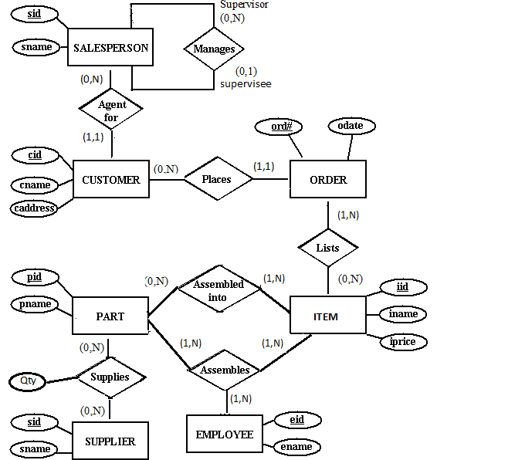

2. Consider the following information about a university database: Professors have an SSN, a name, an age, a rank, and a research specialty. Projects have a project number, a sponsor name (e.g., NSF), a starting date, an ending date, and a budget. Graduate students have an SSN, a name, an age, and a degree program (e.g., M.S. or Ph.D.). Each project is managed by one professor (known as the project’s principal investigator). Each project is worked on by one or more professors (known as the project’s co-investigators). Professors can manage and/or work on multiple projects. Each project is worked on by one or more graduate students (known as the project’s research assistants). When graduate students work on a project, a professor must supervise their work on the project. Graduate students can work on multiple projects, in which case they will have a (potentially different) supervisor for each one. Departments have a department number, a department name, and a main office. Departments have a professor (known as the chairman) who runs the department. Professors work in one or more departments, and for each department that they work in, a time percentage is associated with their job. Graduate students have one major department in which they are working on their degree. Each graduate student has another, more senior graduate student (known as a student advisor) who advises him or her on what courses to take. Design and draw an ER diagram that captures the information about the university. Use only the basic ER model here; that is, entities, relationships, and attributes. Be sure to indicate any key and participation constraints.



3. Notown Records has decided to store information about musicians who perform on its albums (as well as other company data) in a database. The company has wisely chosen to hire you as a database designer (at your usual consulting fee of $2500/day). Each musician that records at Notown has an SSN, a name, an address, and a phone number. Poorly paid musicians often share the same address, and no address has more than one phone. Each instrument used in songs recorded at Notown has a unique identification number, a name (e.g., guitar, synthesizer, flute) and a musical key (e.g., C, B-flat, E-flat). Each album recorded on the Notown label has a unique identification number, a title, a copyright date, a format (e.g., CD or MC), and an album identifier. Each song recorded at Notown has a title and an author. Each musician may play several instruments, and a given instrument may be played by several musicians. Each album has a number of songs on it, but no song may appear on more than one album. Each song is performed by one or more musicians, and a musician may perform a number of songs. Each album has exactly one musician who acts as its producer. A musician may produce several albums, of course.



4.The Prescriptions-R-X chain of pharmacies has offered to give you a free lifetime supply of medicine if you design its database. Given the rising cost of health care, you agree. Here’s the information that you gather: Patients are identified by an SSN, and their names, addresses, and ages must be recorded. Doctors are identified by an SSN. For each doctor, the name, specialty, and years of experience must be recorded. Each pharmaceutical company is identified by name and has a phone number. For each drug, the trade name and formula must be recorded. Each drug is sold by a given pharmaceutical company, and the trade name identifies a drug uniquely from among the products of that company. If a pharmaceutical company is deleted, you need not keep track of its products any longer. Each pharmacy has a name, address, and phone number. Every patient has a primary physician. Every doctor has at least one patient. Each pharmacy sells several drugs and has a price for each. A drug could be sold at several pharmacies, and the price could vary from one pharmacy to another. Doctors prescribe drugs for patients. A doctor could prescribe one or more drugs for several patients, and a patient could obtain prescriptions from several doctors. Each prescription has a date and a quantity associated with it. You can assume that, if a doctor prescribes the same drug for the same patient more than once, only the last such prescription needs to be stored. Pharmaceutical companies have long-term contracts with pharmacies. A pharmaceutical company can contract with several pharmacies, and a pharmacy can contract with several pharmaceutical companies. For each contract, you have to store a start date, an end date, and the text of the contract. Pharmacies appoint a supervisor for each contract. There must always be a supervisor for each contract, but the contract supervisor can change over the lifetime of the contract. 1. Draw an ER diagram that captures the preceding information. Identify any constraints not captured by the ER diagram. 2. How would your design change if each drug must be sold at a fixed price by all pharmacies? 3. How would your design change if the design requirements change as follows: If a doctor prescribes the same drug for the same patient more than once, several such prescriptions may have to be stored.

